**ASSIGNMENT-2**

NAME: M.Ravi Sai Vinay

REG-NO: 192311035

SUBJECT: Python

CODE: CSA0898

1.Converting roman numbers to integers?

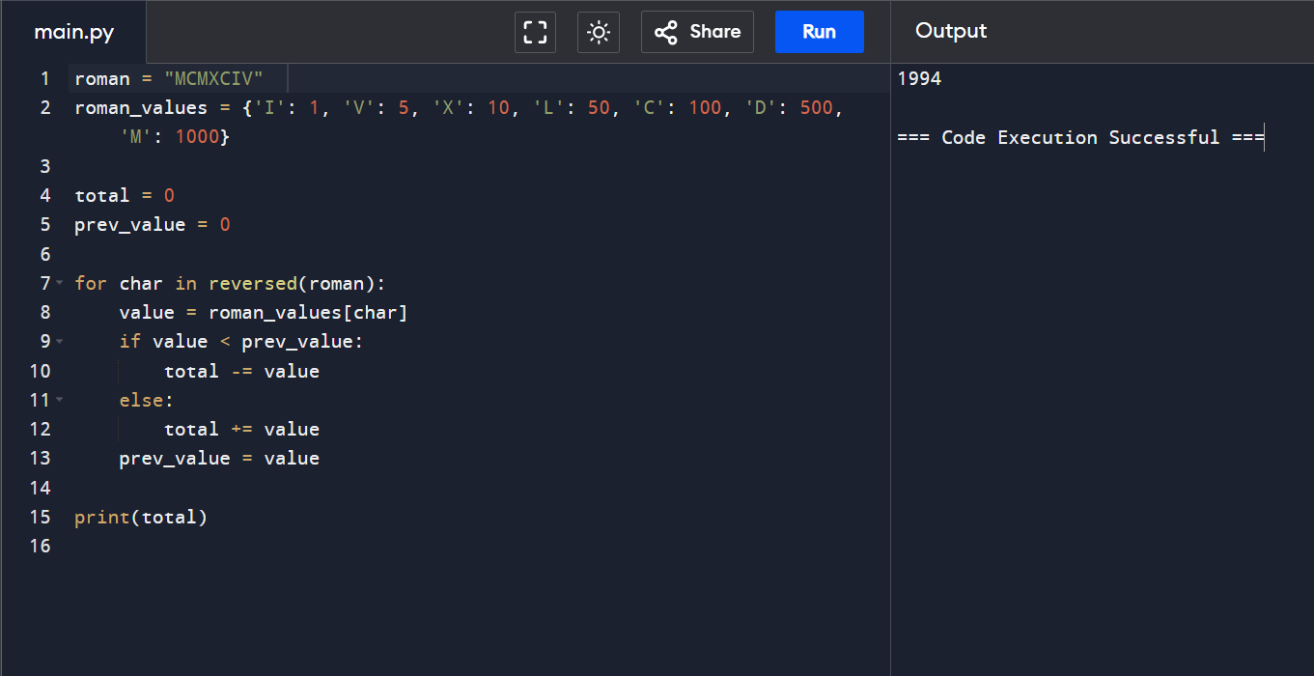

2. write a function to find the longest common prefix string of an array of strings. if there is no common prefix, return an empty string.

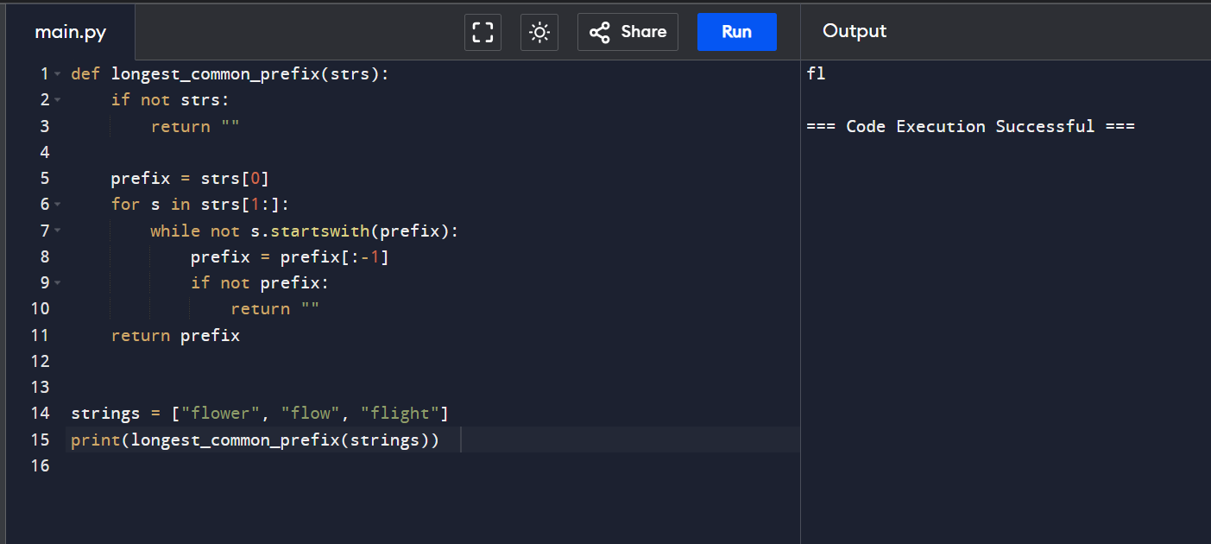

3. Given the root of a binary tree and an integer of target sum return true if the tree has a root to leaf such that adding up all the values?

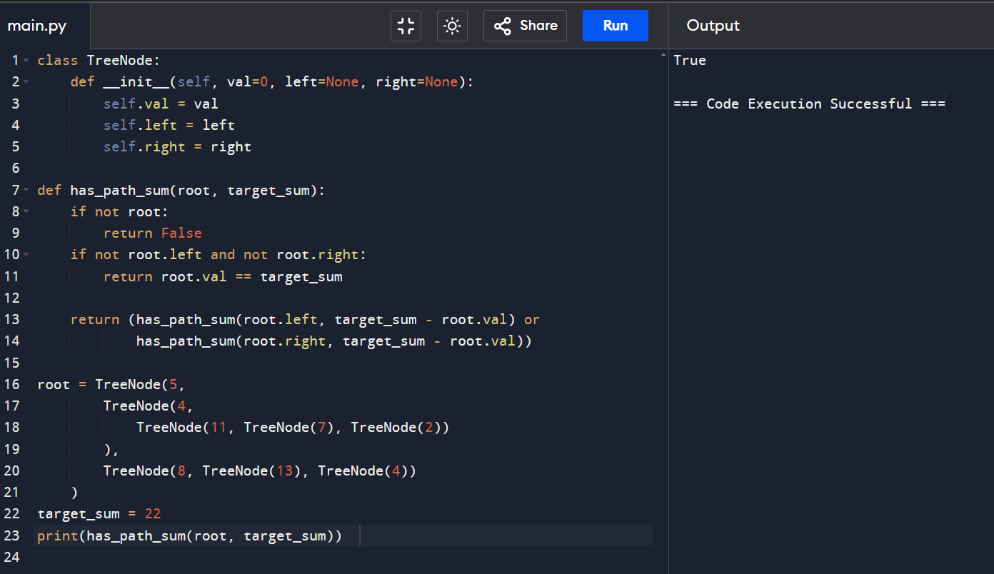

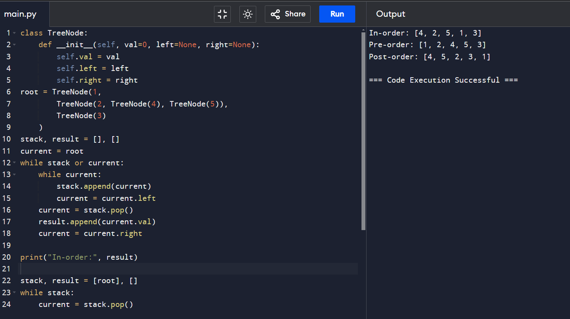4. binary tree traversal?

5. bit reversing?



6. convert sorted array to binary search tree given an integer array nums where the element are sorted in ascending order .convert it to a height-balanced.

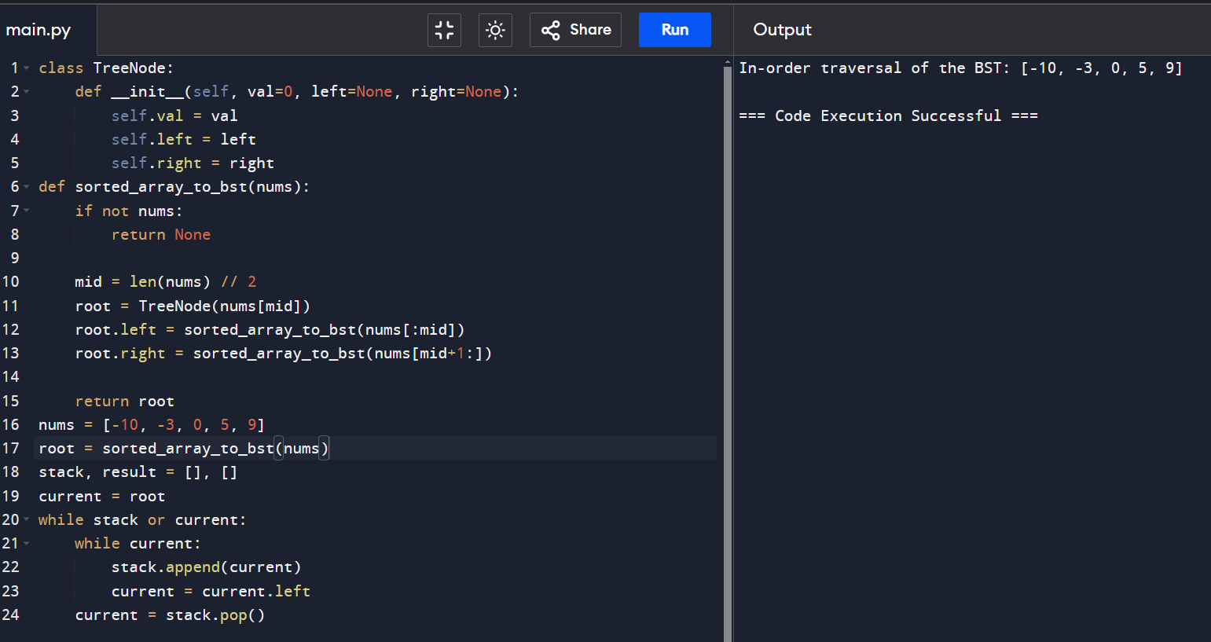

7.Given a binary tree, determine if it is heighted-balanced?

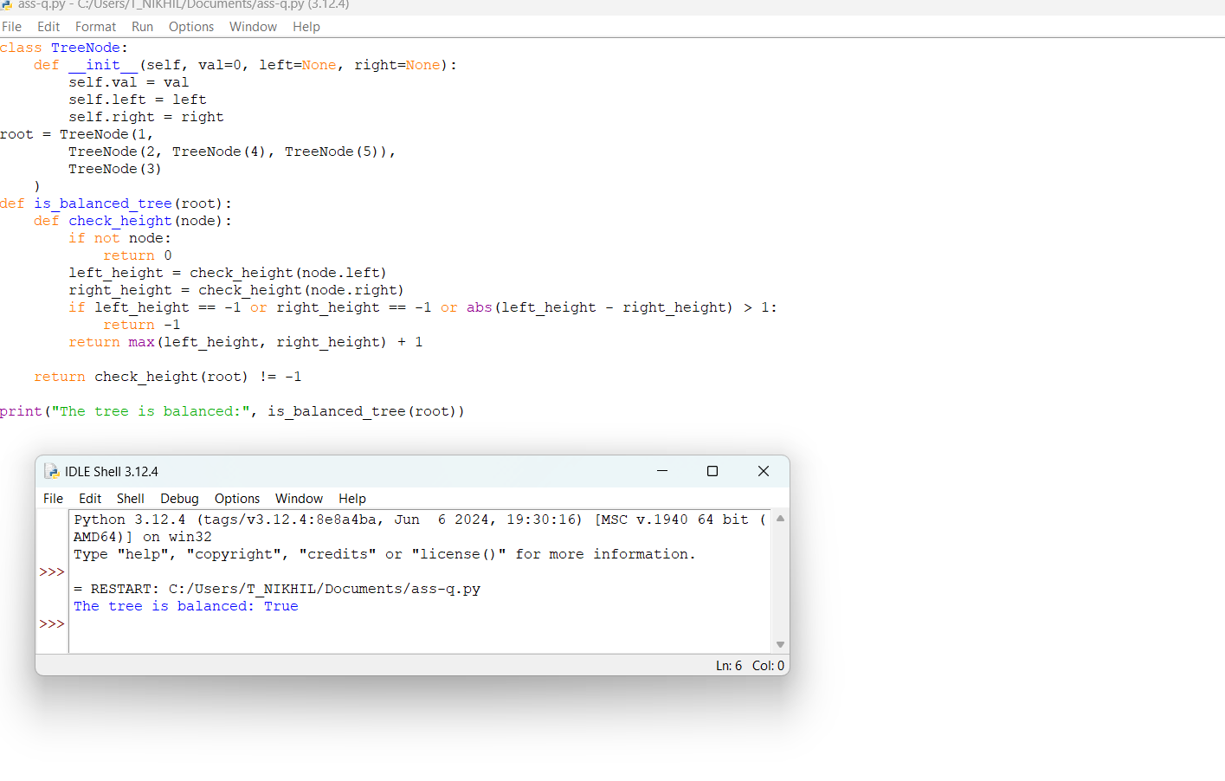

8. climbing stairs, you are climbing a stair case it takes n steps to reach the top each time you can either climb 1 or 2 steps in how may distinct ways can you climb to the top?

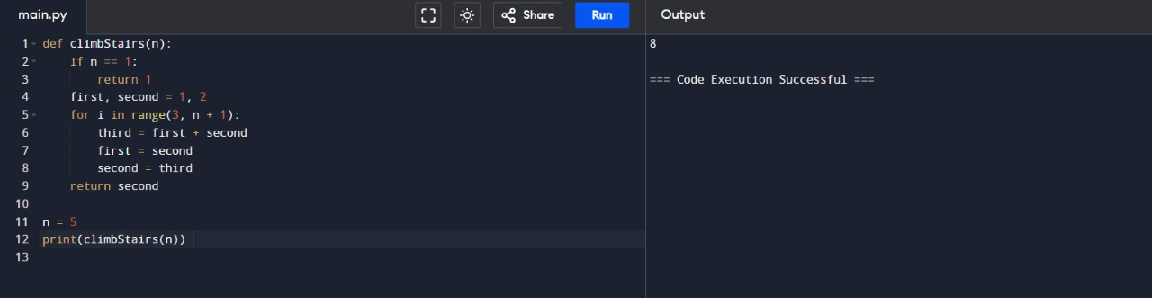

9. best time to buy and see stock ,you are given an array prices e=where prices[i] is the price of a given stock on the ith day. you want to make your profit by choosing a single day in the futher to see stocks if you cannot archieve any profit, return 0

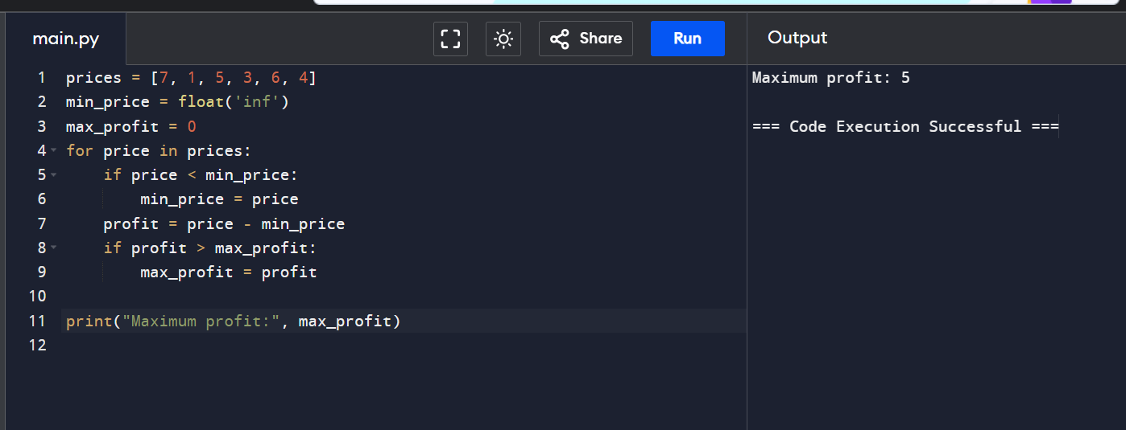

10. Given two binary strings a and b return their sum as a binary string

